PROGRAM-1
AIM-AREA OF TRIANGLE USING FUNCTON
CODE:
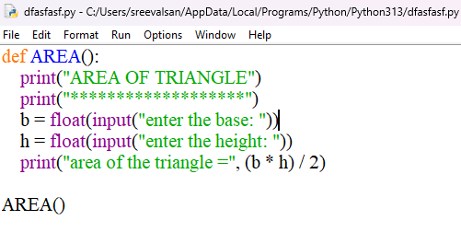
OUTPUT:
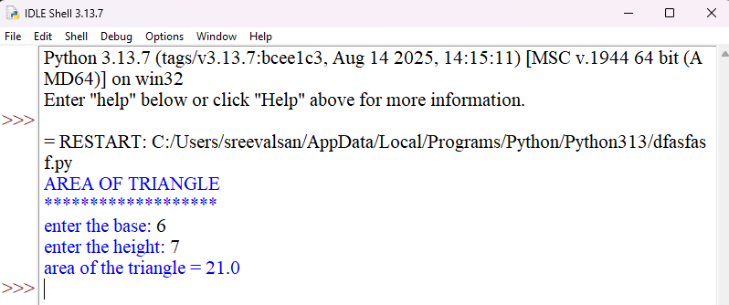

PROGRAM-2
AIM-BASIC CALCULATOR(+,-,*,/)
CODE:
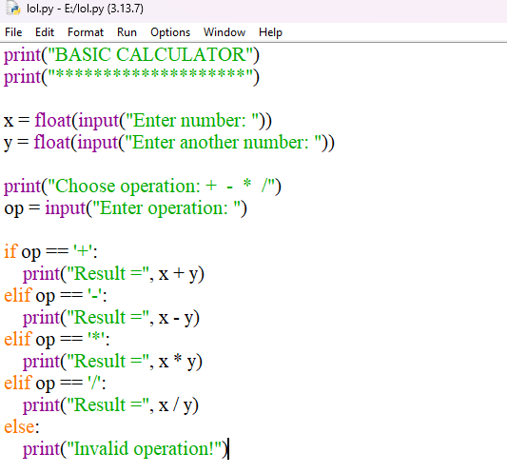
OUTPUT:

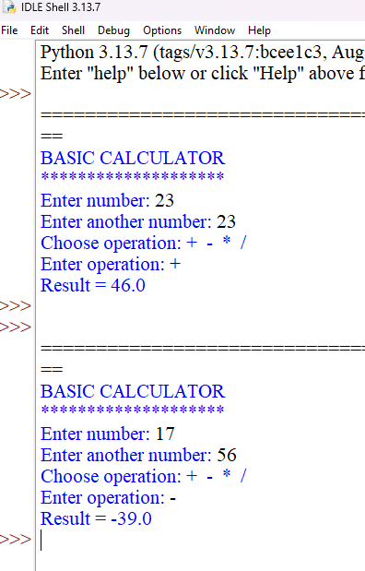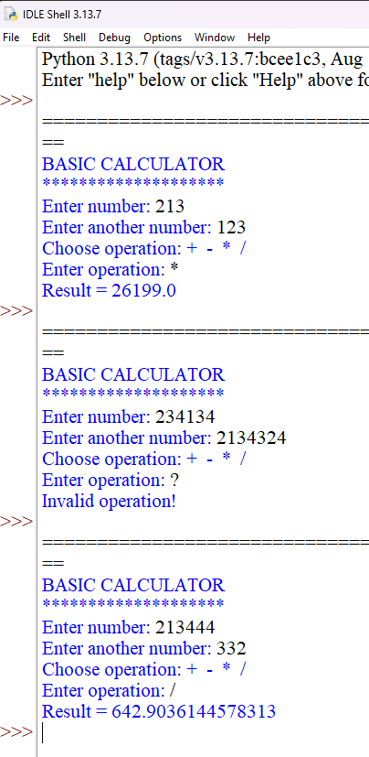

PROGRAM-3

AIM-SQUARE OF A NUMBER USING FUNCTION
CODE:
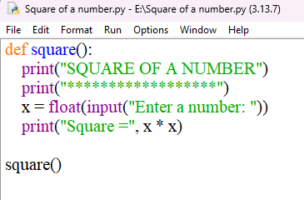
OUTPUT:
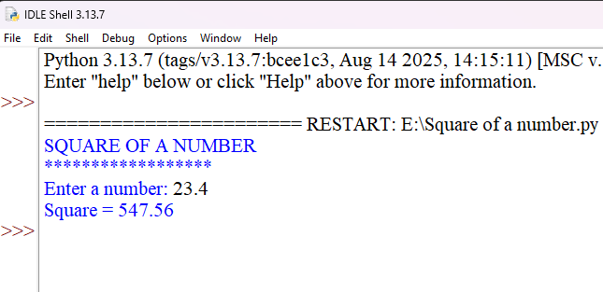
PROGRAM-4
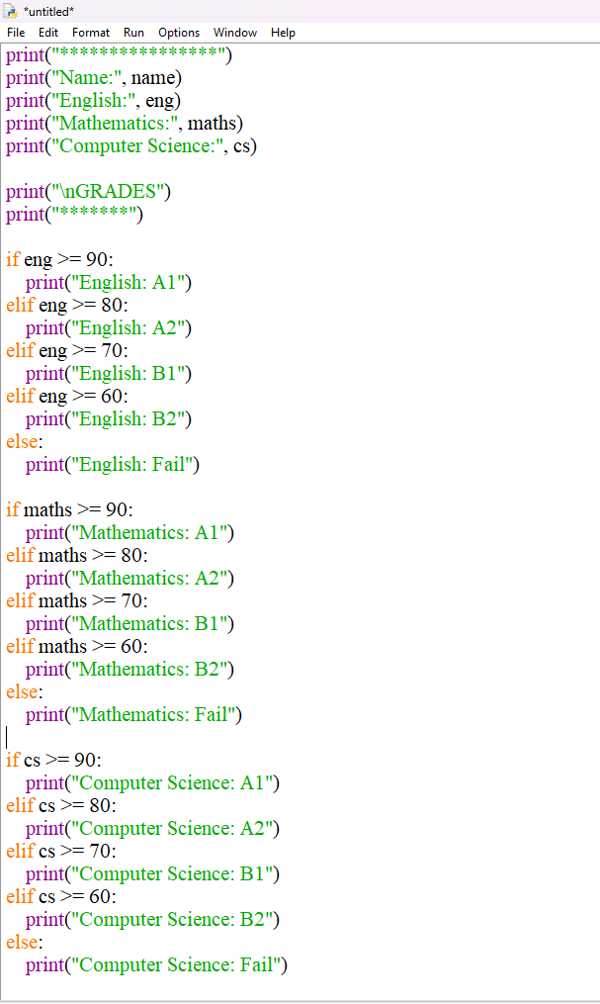

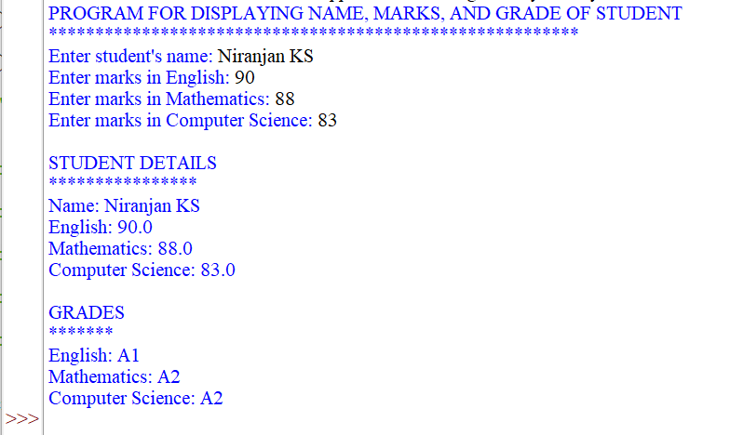
PROGRAM-5
AIM: PROGRAM TO FIND FACTORIAL OF A NUMBER USING WHILE LOOP
CODE:
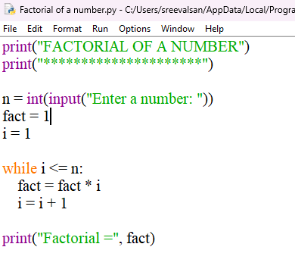
OUTPUT:
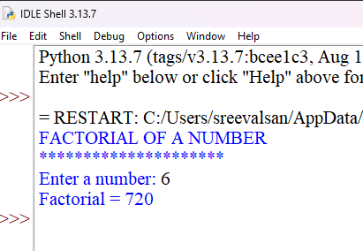

PROGRAM-6
AIM: PROGRAM TO GENERATE THE TABLE OF THE GIVEN NUMBER
CODE:
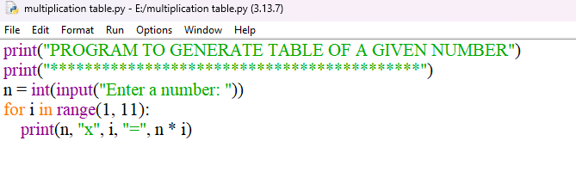
OUTPUT:
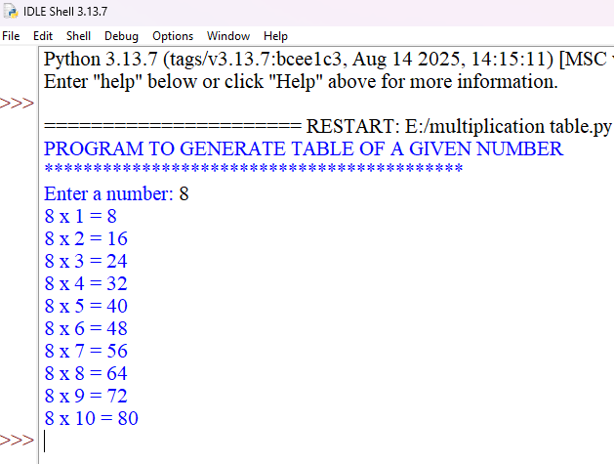

PROGRAM-7
AIM: PROGRAM TO GENERATE NUMBER PATTERN
CODE:
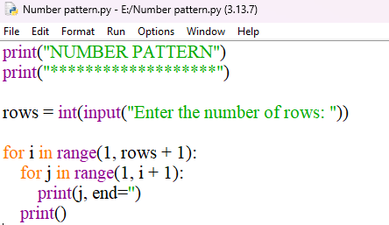
OUTPUT:
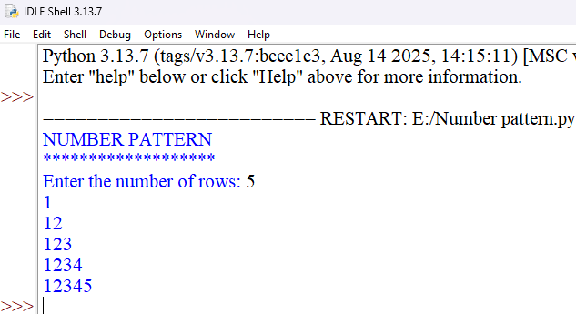

PROGRAM-8
AIM: PROGRAM TO GENERATE STAR PATTERN
CODE:
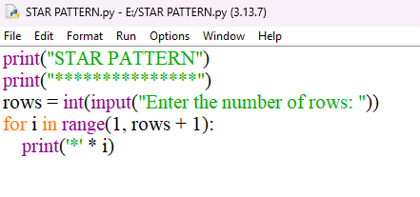
OUTPUT:
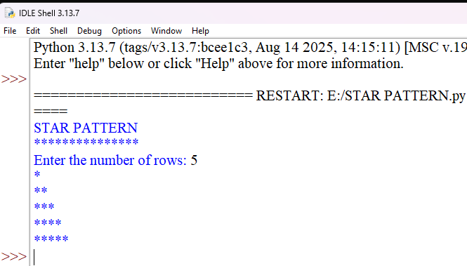
PROGRAM-9
AIM: PROGRAM TO GENERATE PASCAL’S TRIANGLE
CODE:
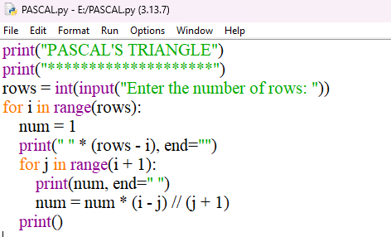
OUTPUT:
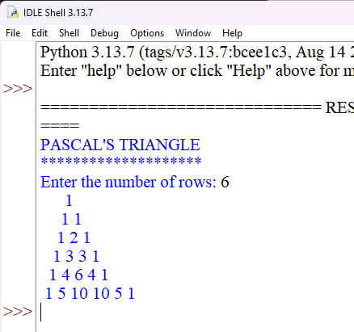
PROGRAM-10
AIM: PROGRAM TO CALCULATE SUM OF FIRST N NATURAL NUMBERS USING FOR LOOP
CODE:
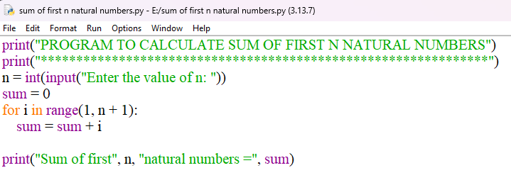
OUTPUT:
